Selenium + Maven + TestNG + Allure Report

Documentation

Step 1:- Install java on the system (Reference Youtube Video:- https://www.youtube.com/watch?v=5b4ZMAjHitw&ab_channel=SDET-QAAutomation)

Step 2:- Download Eclipse from :- <https://www.eclipse.org/downloads/>

Recommended Version :- Eclipse IDE for Java Developers (includes Incubating components)

Version: 2022-06 (4.24.0)

Build id: 20220609-1112

Step 3:- Download and install Maven from the url-

<https://maven.apache.org/download.cgi>

Installation reference <url:-> https://www.javatpoint.com/how-to-install-maven.

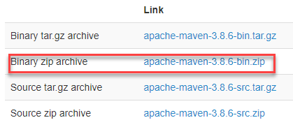

Maven Installation Steps:-

Step1:- Move the extracted maven folder into C drive.

Step2:- Open environment variables and set path on System Variables.

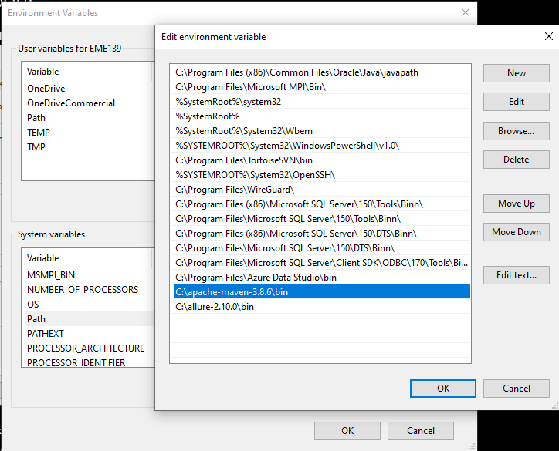

Step3:- Verify the maven installation through command prompt

Run the command :- mvn –version.

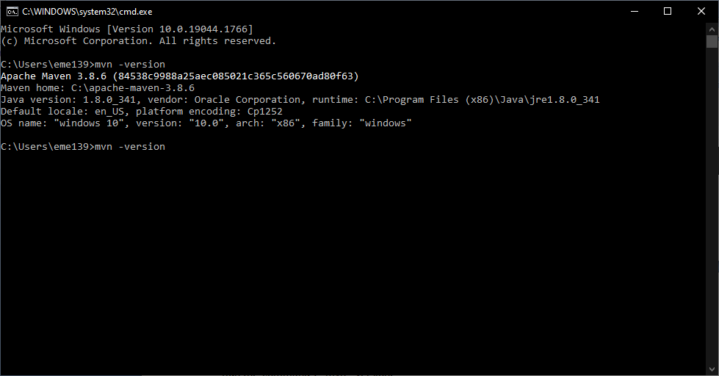

Step4:- Install maven plugin on selenium :-

Reference <url:-> <https://www.javatpoint.com/selenium-maven>

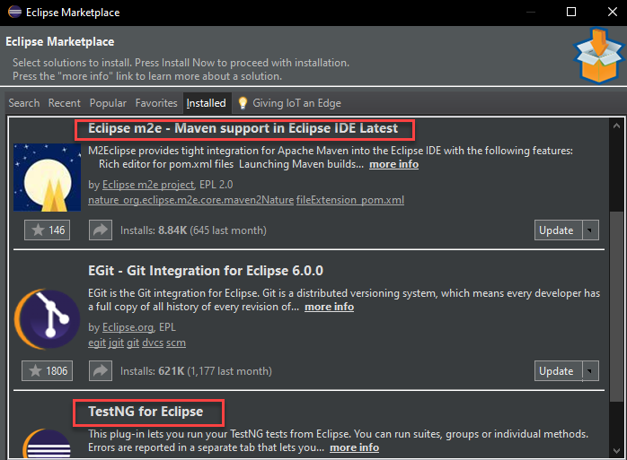

Install the Eclipse m2e plugin from eclipse marketplace.

Step 4:- Install Testng on eclipse from eclipse marketplace

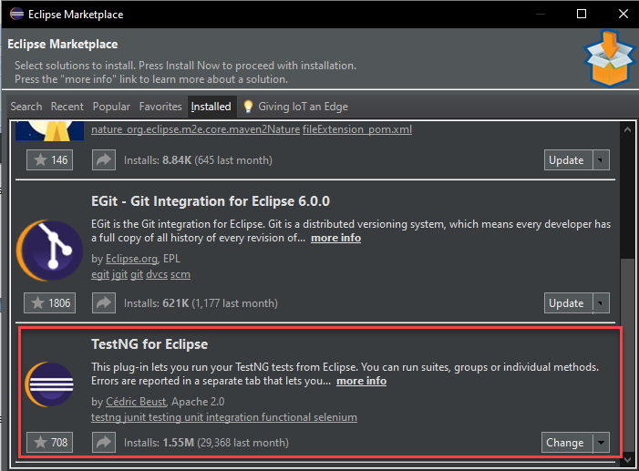

Step5:- Create new Maven project in eclipse

File-> New->Other-> Maven-> Maven Project and Click next

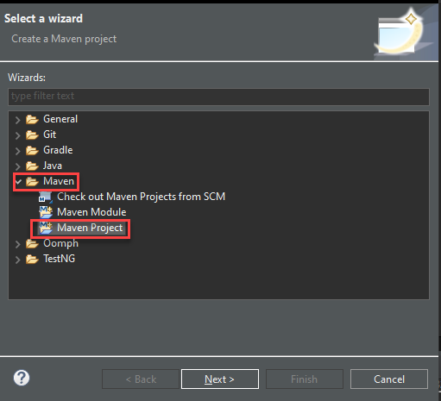

Click Next on the next window

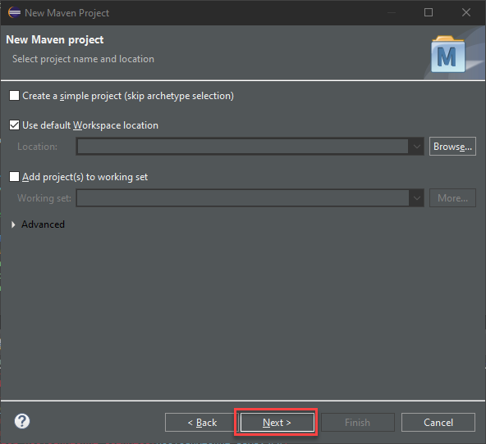

Select the Artifact id ‘maven-archetype-quickstart’ and click next

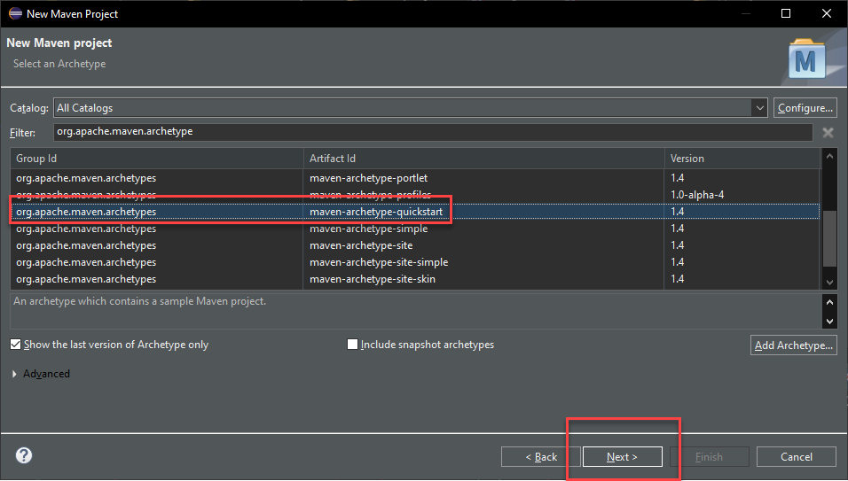

Enter a group id and artifact id and click finish

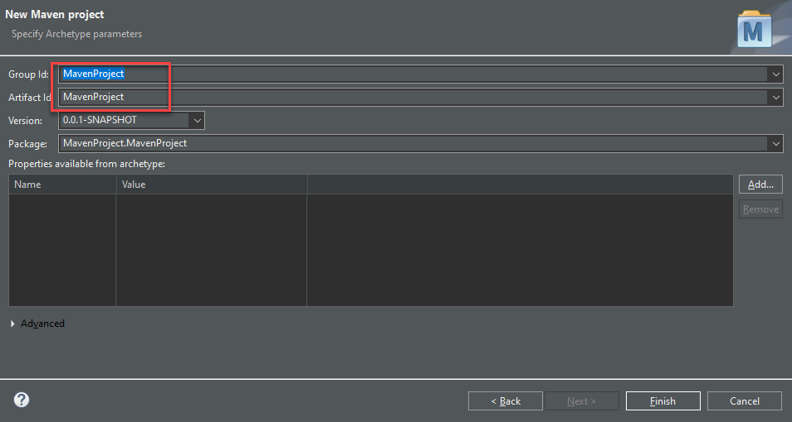

Now the Maven project is created, and the expand the project and delete the default packages created automatically .

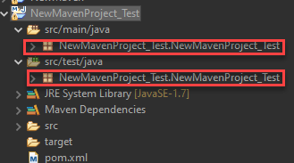

Now open pom.xml file.

Now remove the Junit dependencies which is created by default, we are using Testng .

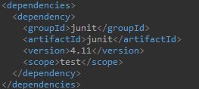

Step5:- Add TestNG dependancy from the url - <https://mvnrepository.com/search?q=testng> into the pom.xml

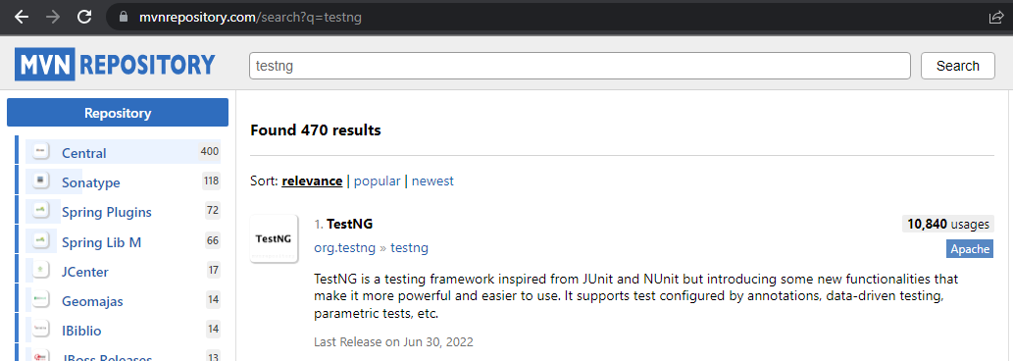

Click on the TestNG link and select the latest version available.

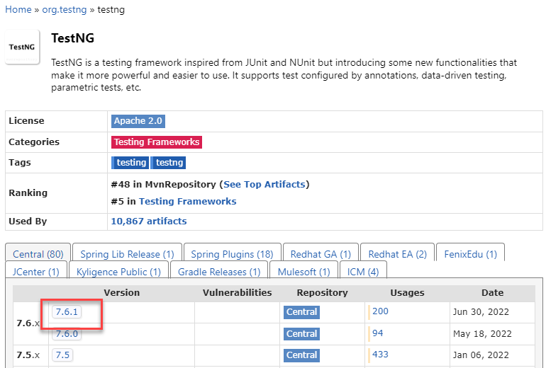

And copy the maven dependency script listed and paste it to the pom.xml file inside the maven project.

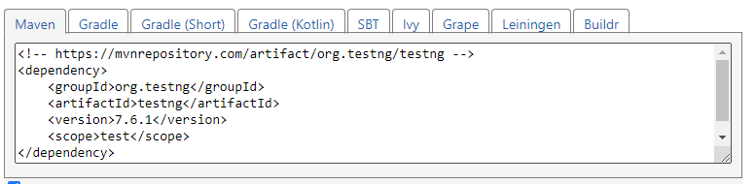

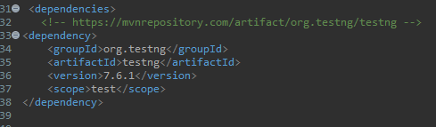

Step6:- Add Selenium Java dependency from the site :- <https://mvnrepository.com/search?q=selenium+java>

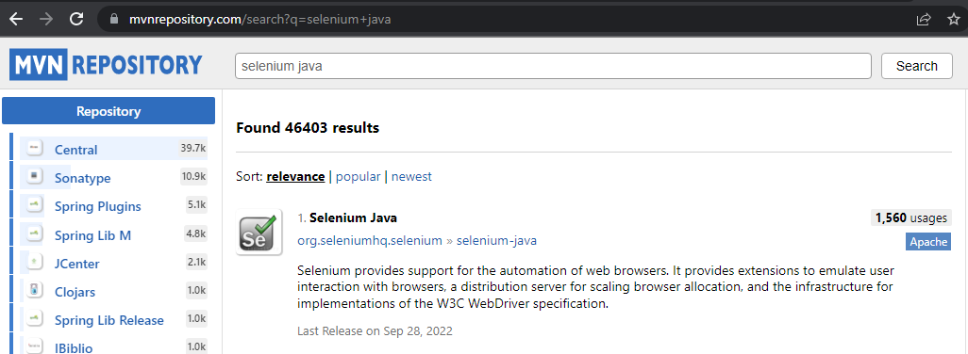

Select the latest version

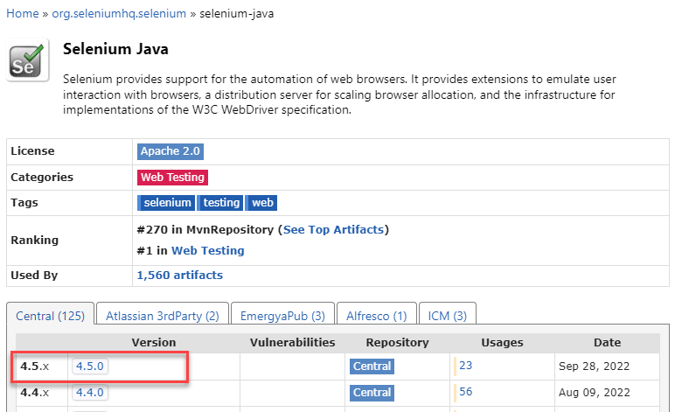

Copy the selenium dependency script and paste it to the pom.xml file.

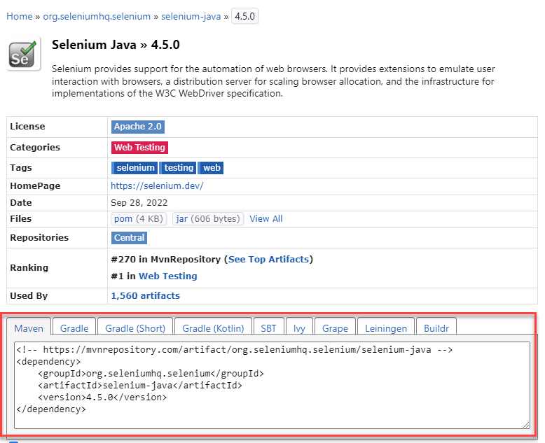

Step7:- Add WebDriverManager dependency from the <url:-> <https://mvnrepository.com/search?q=webdrivermanager>

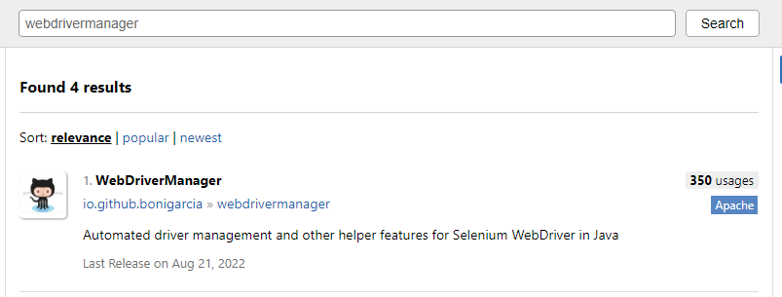

Select the latest version and copy the script and paste it into the pom.xml file.

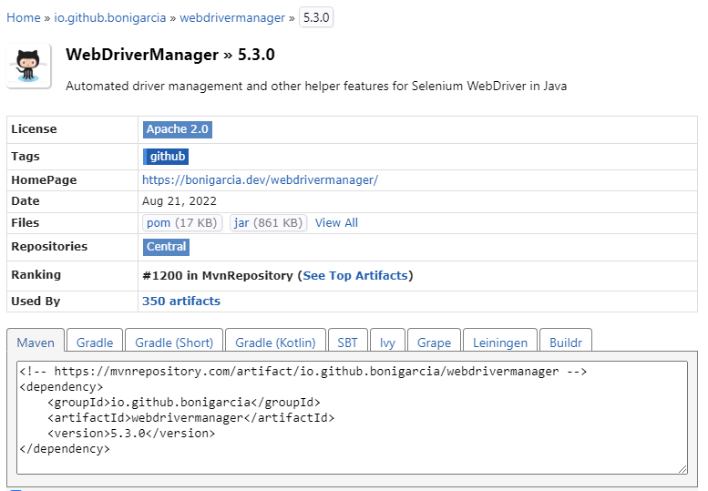

Step8:- Add Allure TestNG dependency from the <url:-> <https://mvnrepository.com/search?q=allure-testng>

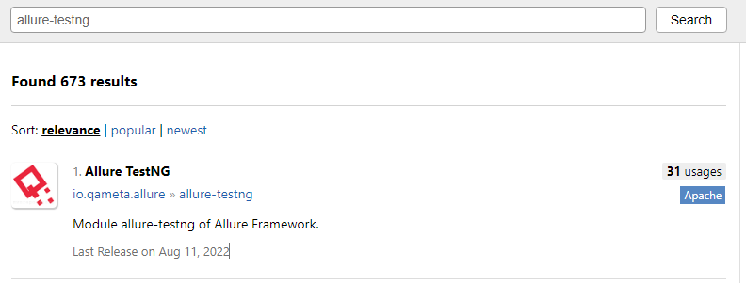

Select the latest version and copy the dependency script and paste it into the pom.xml file

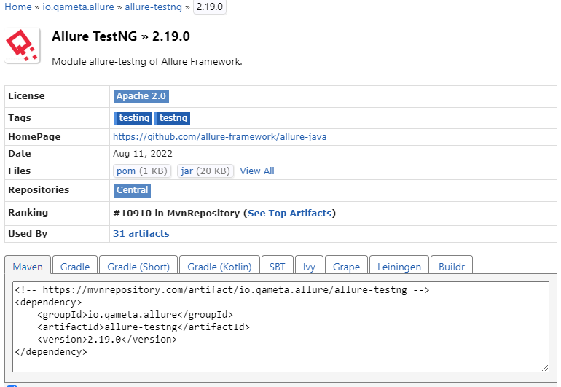

Now completed all required dependencies , Goto the project and right click on the project -> Maven->Update Project-> OK.

Step9:- Install Allure from the below link

Allure Documentation Link :- <https://docs.qameta.io/allure-report/>

Allure download link :- <https://repo.maven.apache.org/maven2/io/qameta/allure/allure-commandline/>

Select the latest version from the list .

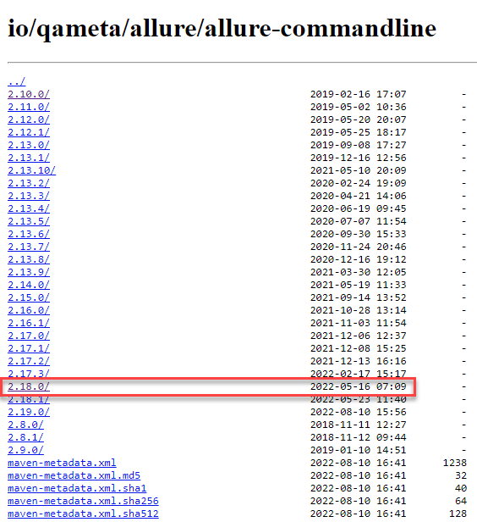

And click on the zip file.

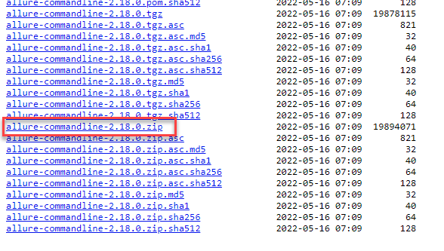

The file will be downloaded.

Unzip the zip file and copy paste the extracted folder to the C drive.

Copy the folder path - C:\allure-2.10.0\bin

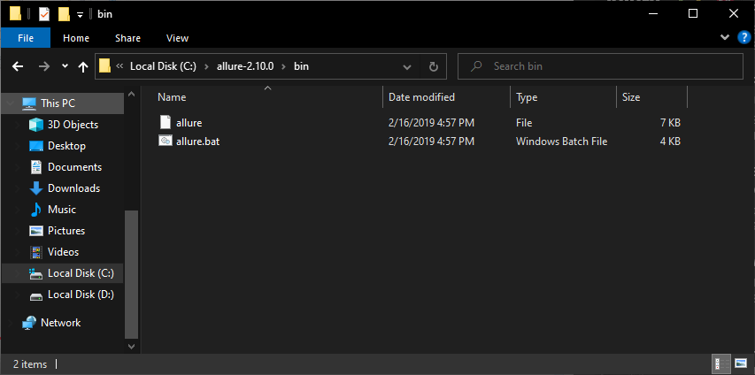

And add the path into the environment variables.

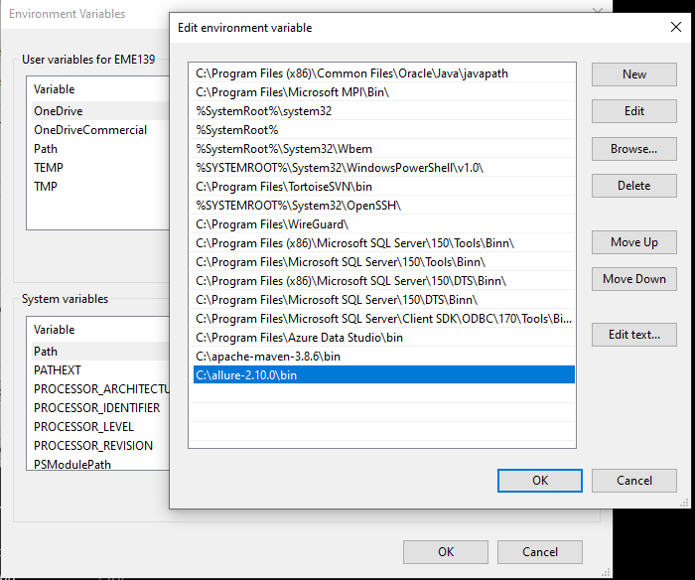

Check the allure version from command prompt using the below command

Allure --version

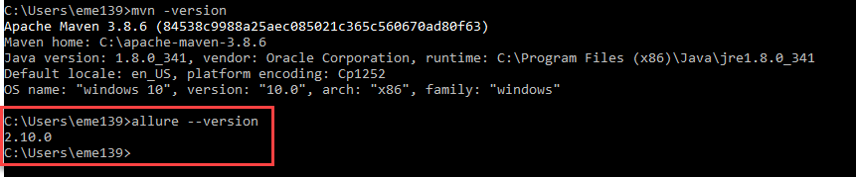

Allure successfully configured.

Step10:- create 3 TestNG test cases which should result 3 status after execution Pass,Fail,Skip to analyze allure report.

Step1:- Create a new java package on the project under the folder src/test/java.

Step2:- Create a new class under the created package.

Step3 :- Create testing test cases.

package testpackage;

import java.util.concurrent.TimeUnit;

import org.openqa.selenium.By;

import org.openqa.selenium.WebDriver;

import org.openqa.selenium.chrome.ChromeDriver;

import org.testng.Assert;

import org.testng.SkipException;

import org.testng.annotations.AfterClass;

import org.testng.annotations.BeforeClass;

import org.testng.annotations.Test;

import io.github.bonigarcia.wdm.WebDriverManager;

public class AllureReport

{

WebDriver driver;

@BeforeClass

public void setup()

{

WebDriverManager.chromedriver().setup();

driver=new ChromeDriver();

driver.manage().timeouts().implicitlyWait(10,TimeUnit.SECONDS);

driver.get("https://demo.nopcommerce.com/");

driver.manage().window().maximize();

}

@Test(priority = 1)

public void logopresence()

{

boolean displaystatus=driver.findElement(By.xpath("/html/body/div[6]/div[1]/div[2]/div[1]/a/img\r\n")).isDisplayed();

Assert.assertEquals(displaystatus,true);

}

@Test(priority = 2)

public void Logintest()

{

driver.findElement(By.linkText("Log in")).click();

driver.findElement(By.xpath("//*[@id=\"Email\"]")).sendKeys("testing@gmail.com");

driver.findElement(By.id("Password")).sendKeys("test123");

driver.findElement(By.xpath("/html/body/div[6]/div[3]/div/div/div/div[2]/div[1]/div[2]/form/div[3]/button")).click();

Assert.assertEquals(driver.getTitle(), "nop commerece 123");

}

@Test(priority = 3)

public void Registerationtest()

{

throw new SkipException("Skip this step");

}

@AfterClass

public void teardown()

{

driver.quit();

}

}

Step4:- Execute the test cases and verify the results.

Step5:- Create TestNG xml file – Right click on the testcase java file and select TestNG -> Convert to TestNG.

Step6:- Open the xml file and right click-> RunAs TestNG Suite.

Step7:- Right click on the project and refresh.

Step8:- Locate the new folder created inside the project named ‘allure-results’, Its generate automatically once the test case executed.

Step9:- Generate Allure Report

Step 1:- Copy the allure-report folder location – Right click on the allure-report folder inside the project -> Properties-> Copy the folder path.

Step10:- Open command prompt and run the command below command along with the copied folder path - allure serve “D:\Works\Selenium Workspace\NewMaven\allure-results” Hit enter.

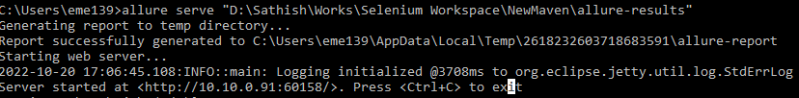

Report will automatically opened in browser.

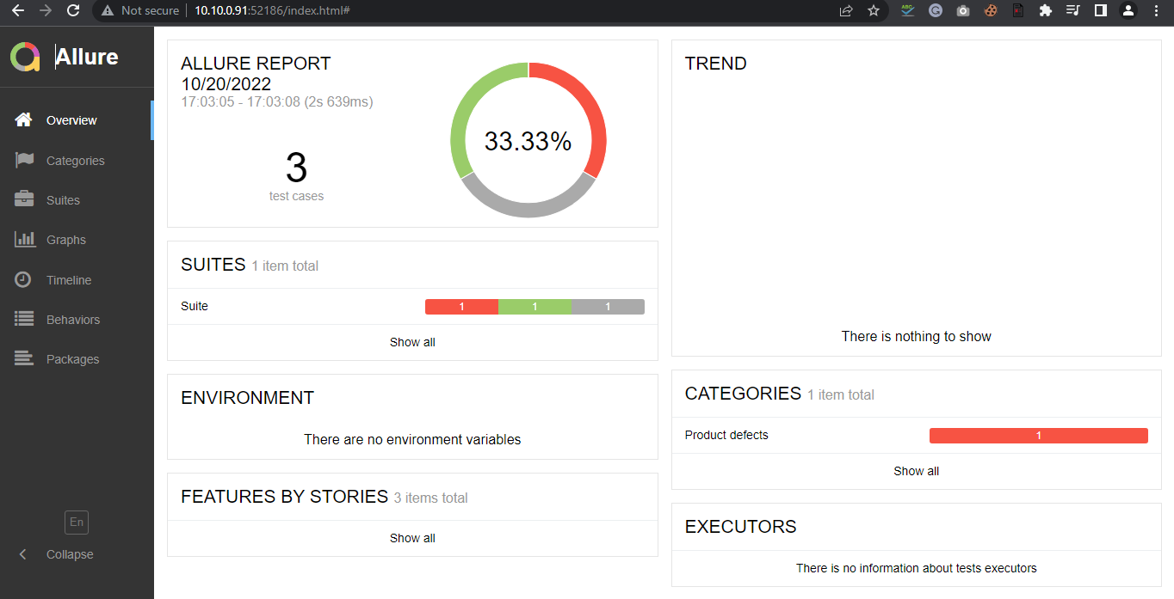

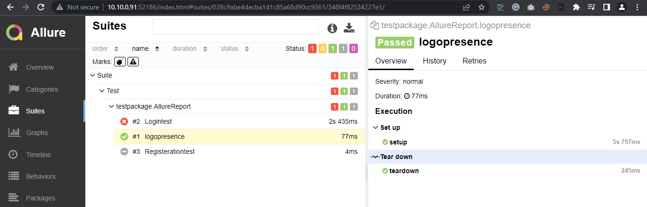

Page Object Model(POM)

* POM is a design pattern in selenium that creates an object repository for storing all webelements.
* It is useful in reducing code duplication and improves test case maintenance.
* In POM Framework, Creates a class for each web page.
* This class file consist of different webelements present on the web page.
* The test script uses these elements to perform different actions.

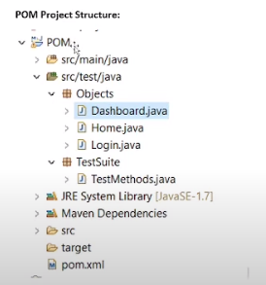

Step1:- Create a new maven project

Step2:- Create new packages Named ‘Object’ and ‘TestScenerios’ under src/test/java.

Step3:- Delete the default java file

Step4:- Open pom.xml file and add required dependencies.

1. Add Selenium dependency.
2. Add TestNG dependency
3. Add webdriver dependency

Step5:- Create new class ‘GoogleSearch’ on Object package